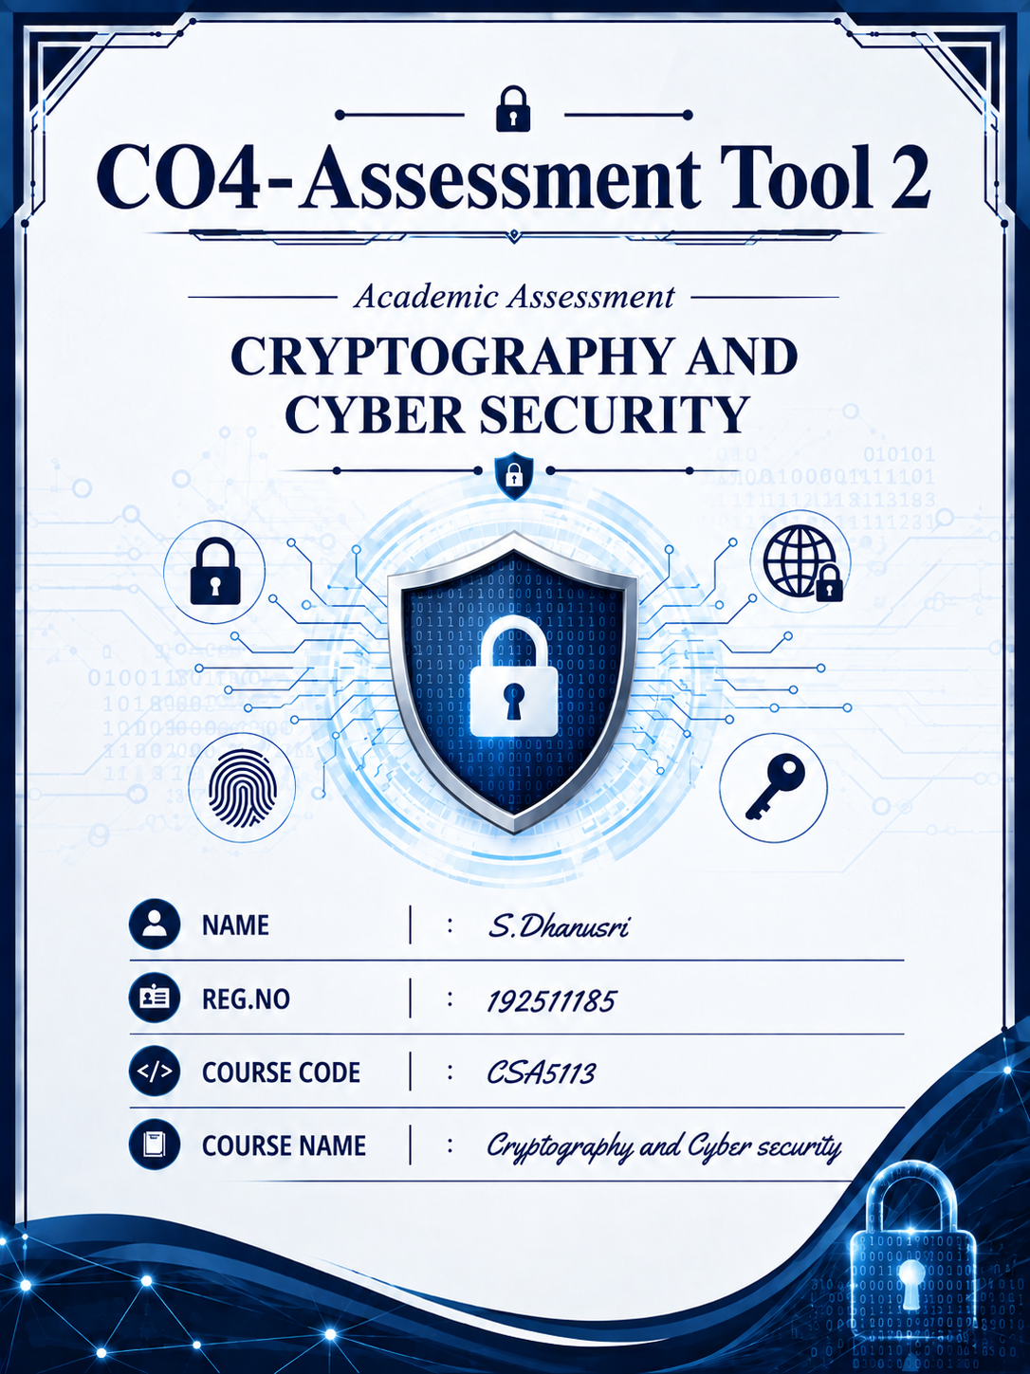
1. IPSec – AH and ESP Configuration
A multinational enterprise can use IPSec to secure communication between branch offices over the public Internet. IPSec provides authentication, integrity, confidentiality, and protection against replay attacks. Authentication Header (AH) provides authentication and integrity but does not encrypt the actual data, whereas Encapsulating Security Payload (ESP) provides confidentiality through encryption along with integrity and authentication when configured with an authentication algorithm.
A. Traffic requiring AH, ESP, or both
- AH: Suitable when data confidentiality is not required but integrity and authentication are important.
- ESP: Preferred for sensitive business data because it provides encryption and protects the contents of the communication.
- AH + ESP: Can be used when both strong authentication/integrity and confidentiality are required, although ESP with authentication is normally preferred because it provides both functions more efficiently.
For example, confidential financial transactions should use ESP, while non-sensitive management traffic may use AH if only integrity and authentication are required.
B. IPSec packet flow and modes
Tunnel Mode:
Branch A → Encrypt/Authenticate entire original IP packet → IPSec Gateway → Internet → IPSec Gateway → Decrypt/Verify → Branch B
Tunnel mode is suitable for branch-to-branch VPN communication, because the complete original IP packet is protected.
Transport Mode:
Original IP Header + IPSec Header + Encrypted Payload → Destination
Transport mode is suitable when the end systems themselves implement IPSec and only the payload needs protection.
C. Protocol selection
ESP should be selected for confidential information such as financial records, customer information, and business documents. AH can be used for traffic where confidentiality is unnecessary but authentication and integrity are important. For most enterprise VPNs, ESP in tunnel mode provides a practical combination of confidentiality, integrity, and authentication.
D. Performance vs. security trade-off
AH requires less processing because it does not encrypt data, but it provides less protection. ESP requires additional processing for encryption and authentication, which can introduce some overhead. However, the additional overhead is justified for sensitive enterprise traffic because confidentiality and integrity are critical.
Recommendation: Use ESP tunnel mode with strong encryption and authentication for branch-office VPNs.

2. IPSec Security Association and Key Management
The organization is experiencing expired and mismatched keys because Security Associations (SAs) and key exchange are not being managed efficiently. The solution should automate SA creation, key exchange, renewal, and revocation using an IKE-based key-management mechanism.
A. Current SA lifecycle issues
Common problems include:
- Manually configured keys becoming expired.
- Different devices having mismatched keys.
- Failure to renew keys before their lifetime expires.
- Difficulty maintaining SAs across many branch offices.
- Improper deletion of old or compromised SAs.
- Lack of centralized monitoring.
These problems become difficult to manage as the number of VPN connections increases.
B. Automated IKE-based mechanism
The organization should implement IKE (Internet Key Exchange) to automate the creation and management of IPSec SAs.
A simplified process is:
Initiator → IKE Negotiation → Authentication → Key Exchange → Establish IKE SA → Establish IPSec SA → Secure Communication
IKE automatically negotiates security parameters and generates shared session keys instead of requiring administrators to manually configure keys.
C. Key renewal and revocation
Key renewal should occur automatically before the SA lifetime expires. New keys should be generated periodically using fresh key-exchange material.
If a key or device is compromised:
Detect compromise → Revoke credentials → Delete SA → Generate new keys → Establish new SA
Centralized certificate or credential management can also be used to revoke compromised identities.
D. Scalability and fault tolerance
An automated IKE-based system is highly scalable because new branch offices can establish SAs without manually configuring every key. Redundant VPN gateways, backup authentication servers, and centralized monitoring can provide fault tolerance.
Recommendation: Implement IKE-based automated key exchange with automatic SA renewal, centralized monitoring, key revocation, and redundant gateways.

3. PGP vs S/MIME for Secure Email
A financial services company needs secure email for sensitive transactions. The two major alternatives are PGP (Pretty Good Privacy) and S/MIME (Secure/Multipurpose Internet Mail Extensions). The assessment specifically requires comparison based on usability, scalability, key management, trust models, and enterprise integration.
A. PGP vs S/MIME
Feature | PGP | S/MIME
Trust model | Decentralized / Web of Trust | Certificate Authority (CA) based
Key management | User-oriented | Enterprise/centralized
Enterprise integration | Moderate | High
Usability | Can require technical knowledge | Generally easier in enterprise environments
Certificates | Not necessarily CA-based | Uses X.509 certificates
Scalability | More difficult for large organizations | Better suited for large enterprises
Email client support | Depends on implementation | Widely integrated into enterprise email clients

B. Key management and trust
PGP commonly uses a decentralized trust model where users can verify and sign each other's public keys. This provides flexibility but can make large-scale management more complicated.
S/MIME uses digital certificates issued by trusted Certificate Authorities. The certificate binds a user's identity to their public key, making centralized enterprise management easier.
C. Recommendation
For a financial services company, I recommend S/MIME because it provides better enterprise integration, centralized certificate management, and a structured trust model.
PGP can be appropriate when users need greater control over their keys or when decentralized trust is preferred.
D. High-level S/MIME workflow
User requests certificate → CA verifies identity → Certificate issued → Public key distributed → Sender digitally signs/encrypts email → Receiver validates certificate → Receiver decrypts/verifies email
This approach provides confidentiality, authentication, integrity, and non-repudiation.

4. Advanced Spam and Phishing Detection
The company's existing email filtering is unable to adequately detect phishing and spam attacks. An improved system should analyze both email headers and message content, using rule-based techniques and/or machine learning.
A. Limitations of existing filtering
Basic filtering may depend mainly on:
- Sender address
- Simple keyword matching
- Known spam lists
- Fixed filtering rules
Attackers can bypass these techniques by changing sender information, using newly created domains, modifying message content, or using sophisticated phishing techniques.
B. Email header analysis
The system should examine:
- From address
- Reply-To address
- Return-Path
- Sending IP address
- Received headers
- SPF results
- DKIM results
- DMARC results
- Domain reputation
For example, if the visible sender claims to be from a bank but the actual sending domain is unrelated, the message should receive a high-risk score.
C. Improved detection model
A hybrid system can combine rule-based filtering and machine learning.
Example:
Email → Header Analysis → Content Analysis → URL Analysis → Reputation Check → ML Risk Score → Spam/Phishing Classification
The ML model can consider features such as suspicious URLs, unusual sender behavior, message keywords, domain age/reputation, header inconsistencies, and authentication failures.
D. Effectiveness and false positives
The system should assign a risk score rather than immediately deleting every suspicious email.
For example:
- Low risk: Deliver normally.
- Medium risk: Deliver to spam/quarantine.
- High risk: Block and alert the security team.
Regularly updating rules and retraining the model can improve detection while reducing false positives.
Recommendation: Use a hybrid header + content + reputation + ML-based detection system.

5. S/MIME Certificate Management
The security audit identified vulnerabilities caused by improper S/MIME certificate handling. The organization should ensure correct certificate issuance, storage, validation, renewal, and revocation.
A. Certificate-related vulnerabilities
Possible problems include:
- Expired certificates.
- Invalid or revoked certificates.
- Incorrect certificate-to-user mapping.
- Weak private-key protection.
- Untrusted Certificate Authorities.
- Failure to verify the certificate chain.
- Compromised or exposed private keys.
- Incorrect certificate configuration in email clients.
B. Trust chain and validation
S/MIME certificates should be validated through the certificate trust chain:
User Certificate → Intermediate CA → Root CA
The email client should verify:
- Certificate validity period.
- Certificate signature.
- Trusted CA.
- Certificate revocation status.
- Identity of the certificate owner.
- Intended certificate usage.
If any important validation fails, the certificate should not be trusted.
C. Secure certificate storage and management
The organization should:
- Protect private keys using strong encryption.
- Use secure key stores where possible.
- Restrict access to private keys.
- Maintain centralized certificate management.
- Monitor certificate expiration.
- Renew certificates before expiration.
- Revoke compromised certificates immediately.
- Maintain backups of required certificates securely.
D. User awareness and system configuration
Employees should be trained to recognize certificate warnings and suspicious emails. Email clients should be configured to automatically validate certificates and check revocation status.
Administrators should regularly audit certificates and remove expired or compromised certificates.
Recommendation: Implement a centralized S/MIME certificate lifecycle management system with secure private-key storage, CA validation, automatic expiry monitoring, certificate revocation, and user training.

